Conquering Rhetorical Analysis: Unpacking the Suitcase of Language

Timm Freitas
Whitinsville Christian School
279 Linwood Ave, Whitinsville, MA 01588
TimmFreitas@gmail.com

Introduction

This document provides a—somewhat—succinct review of reading and writing strategies that apply to Question 2 of the AP English Language exam. Although this document focuses on how the strategies below work in relation to the AP English Language exam, it should be noted that following similar processes when approaching Questions 1 and 2 on the English Literature exam may also make it easier for students to create well-developed responses to said questions.

Please know that you will find all of my templates on the following pages in GREEN. Examples of these templates in action are in BLUE. I have put all of the templates on page 16 of this document. On the last page you will also find an analysis template for struggling students. This final template, however, is not exemplified anywhere else in the document. One other idea you should note before reading further: even though the templates in the document stem from breaking down AP prompts and creating questions, you can still use this guide and the accompanying templates to teach your students how to rhetorically analyze without prompts. Instead of using prompts, students will just have to be taught to search for the speaker’s claim and purposes without having someone tell them to do it.

Where to Begin: Definitions in Rhetoric

Before we can get students to break down rhetorical analysis prompts and write about them effectively, we absolutely must create common definitions for rhetorical practice. In the following few lines, I will provide you with my definitions of rhetoric, rhetorical device, rhetorical strategy, and purpose. Some individuals may choose to disagree with my definitions, and that is fine; however, I want to make sure that when you read these terms throughout the document, you understand what I mean so that everything is entirely clear.

Rhetoric: Using language to construct meaning

Rhetorical Device: Anything (honestly, anything at all!!!!) that a speaker USES to construct meaning

Rhetorical Strategy: Anything a speaker DOES to construct meaning

Purpose: What the audience is supposed to understand and do after experiencing the discourse

I ended with the definition of purpose because all of what the following techniques center around is exactly that: being purposeful—whether it is becoming a purposeful reader, reading the work of a purposeful writer, or becoming a purposeful writer of a purposeful essay that analyzes the work of another purposeful writer. Focusing on PURPOSE must dictate all of the actions that students partake in after they receive their AP exams, or anything else for that matter. So, to get students to understand purpose, I simplify the term into two layers: to inform and to persuade.

I tell students that the element of understand matches up with to inform, and the element of do matches up with to persuade; both are common phrases tied to types of purpose. Now, I do understand that there are other elements of purpose in writing: to entertain, to aesthetically please, etc., but the reason why I break it down to only these elements is two-fold: First, even if the purpose is to entertain, that still requires an individual to prompt another to experience positive emotions in relation to what is being presented. Creating the experience within another individual moves that other person to do something emotionally, and sure enough, that doing entails an element of persuasion, so other types of purpose essentially fit into the to persuade category (once we play with semantics a bit). Second, defining purpose as I do adds layers to student analysis, and such considerations tie into their other essays. That is, if students know that they need to navigate two layers in order to explain how evidence informs and then MOVES the audience, they will have complex analysis every time as they work through layers of meaning. This idea of layered purpose consequently may help them better conceptualize their own essays for synthesis and argument because they will then know that they need to consider the following questions—What is it that I want to inform the audience in relation to my claim? What is it that I want my audience to do with that information? –when they write their own pieces. If students conceptualize their writings purposefully, they should have a better way of conceptualizing their arguments and writing their conclusions: Their essays must present information that may move individuals to act and their conclusion, especially, must prompt some action in response to the topic discussed in the paper, even if it is mere contemplation. Prompting the audience to laugh, ponder, or any other seemingly dormant task, is still persuasive if the audience is MOVED to do something based on information provided by a speaker.
A Garden of English Production: GardenofEnglish2019©

Next Steps: AP: Answering the Prompt by Breaking Down the Prompt

Contrary to popular student belief, AP does not stand for Anxiety and Pressure, Agony and Pain, or even Advanced Placement. It really stands for Answer the Prompt. The problem is that many students don’t realize how much the prompts themselves can assist in helping them—the students—answer the prompts in rather sophisticated manners, so this next section will detail how I have students break down prompts—particularly in relation to question 2 for the AP English Language Exam—in a manner that will give them purpose for reading the essay that follows the prompt and give them purpose for writing the analytical essay in response to the prompt.

In order to understand some of the lingo in my templates, you will have to know how I have my students break down the rhetorical analysis prompt BEFORE they begin reading the essay. Like I said, the reason why I have students break down the prompt the way I do is so they can create a purpose for reading the essay—besides having to write about it—and so that they can be empowered to write about what they know, as opposed to what they don’t.

I have students identify the standard elements in a prompt: exigence, speaker/author, audience, title of the work (if there is one), and genre/medium. This is a pretty common technique, but what you will see below in my chart is that I also have students identify and create what I have titled the Command and the Conquer elements of the prompt. I use this language because it allows my students to picture they are going to war with their rhetorical analysis essay; and once they receive their command, they can devise a way to conquer the territory: the excerpt for analysis. Of all of the things I do with my students, the most important step of this whole process—before they use my templates—is having them create the Conquer Question BEFORE reading the excerpt they need to analyze. If you check out what’s below, you’ll see how I instruct students to break down the prompt and ultimately generate the mighty Conquer Question:

Reading the Prompt: The Steps

- First, students must start breaking down the prompt by identifying the TAG (Title, Author, and Genre). This information is found in most AP Prompts. They must label each with a T, an A, and a G respectively. If students are unable to find one of the elements, I tell them to skip it and then go back to reevaluate once they have completed all other tasks of the prompt breakdown. This is especially pertinent in relation to prompts that involve speeches and letters as they often do not have titles. If students run into this, they should know that all they need to do is combine the speaker and genre to create a non-punctuated, informal title that they will refer to later on in their thesis statements. (e.g., In Banneker’s letter to Jefferson…, Throughout Caesar Chavez’s article…, etc.)

- Second, students must evaluate elements of exigence presented in the prompt. This is commonly found in the first few sentences of the prompt itself. I tell them to look for three particular elements that relate to exigence: information about the author, information about the audience, and information about the essay they are about to read. I have them mark this with little stars on the prompt.

- Third, students move to identifying the Command element of the prompt. The Command is a simple way that I force students to focus on the SAME THING every time they read a prompt. Essentially, I have them constantly remind themselves that they need to ANALYZE in their papers, not merely summarize, describe, or identify. So, locating the Command always requires them to find the word (or variant) of “analyze”’; then, students must underline from analyze to the end of the sentence. Like I said, this is a reminder technique.
A Garden of English Production: GardenofEnglish2019©
- Finally, and most important, students must create the Conquer Question. Remember, this is the MOST IMPORTANT element in this whole process. Generating this question is done by looking in the Command for the authorial action verb that follows the word “analyze.” The key verb here is USUALLY, but not always, the infinitive that follows the word (or variant) of “analyze.” Once students have found the infinitive, students must double underline from the infinitive to the end of the sentence. Then, they generate a question by asking themselves, “While only looking at the double underlined text, what can’t I know until I have actually read this essay?” THE QUESTION THEY CREATE MUST START WITH THE WORD “WHAT”!!!!! This question also may not have anything to do with the words rhetorical strategies, rhetorical choices, and or crafts the text; all of these phrases fall outside of the double underlined area. Students may not look outside that area of the prompt to create this question. In my experience, students struggle with this at first, so I consistently remind them that they must only look at the words that are DOUBLE UNDERLINED and ask “What don’t I know?” Again, you’ll see that rhetorical strategies is not double underlined; therefore, it can’t be in their question.

Now, with the Conquer Question generated, students should focus on reading the passage for the sole purpose of answering this question; however, the answer to this question must be considered in relation to the purpose(s) of the piece. That is, students need to answer this question on the levels of to inform and to persuade. This is because often times the generated question will have students focus on the speaker’s message, the speaker’s characterization, the speaker’s attitude (tone), or the speaker’s argument, not necessarily the speaker’s purpose (with the exception of the JFK prompt found on the 2012 exam). When you instruct students to intrinsically add in the layers of finding elements of purpose, you are instructing them to complexly identify the intricacies of meaning that manifest themselves within the text: the core message of a text relates to how the author conveys information which ultimately moves the audience to act. The AP exam is a complex test that tests students’ abilities to complexly delve into texts.
Two things to note:
First, I have examples below that will exemplify how to break down prompts, find the Command and Conquer, and answer them with purpose in mind. I know that this may sound overly complicated, but when you see it in action, I think you’ll see that it’s not as cumbersome to navigate as this the above text may have it seem.
Second, if you think that adding the analytical reading layers of to inform and to persuade may be too difficult for where your students are at, just have them answer the conquer question without considering the added elements of purpose, and if they can do that, they will still be putting themselves in position to write 6-7s on their rhetorical analysis essays, especially if they use the attached templates. The reason why I have added the elements of to inform and to persuade is because I’m under the impression it will encourage students to turn adequate analysis into effective analysis, thus moving typical scores from the 6-7 range to the 8-9 range. For my prompt breakdowns below, I will provide two examples of each. The first will be a breakdown where the Conquer Question is answered without focusing on discussing layers of purpose (to inform/to persuade), and the second will exemplify how to answer the Conquer Question while considering elements of purpose. Let’s see some examples:

A Garden of English Production: GardenofEnglish2019©

Prompt: The passage below is from the opening of an essay, “On Seeing England for the First Time,” by Jamaica Kincaid. Kincaid grew up on the Caribbean island of Antigua before it became independent from England in 1981. Read the entire passage carefully. Then write an essay analyzing the rhetorical strategies Kincaid employs to convey her attitude toward England.
Write out the Conquer Question:

TAG | Background info for thesis | C and C | Conquer Answer
T: “On Seeing England for the First Time”  A(Speaker):  Jamaica Kincaid  G: Essay | - Grew up in Antigua before it was independent  - Independence was gained in 1981 | Command:  Analyz[ing] the rhetorical strategies Kincaid employs to convey her attitude toward England.  Conquer:  What is her attitude toward England? | - Disdain  - Resentment (particularly towards colonialism’s ability to establish prejudices and demean other cultures)

Without Considering Elements of Purpose in the Conquer Answer:

TAG | Background info for thesis | C and C | Conquer Answer
T: “On Seeing England for the First Time”  A(Speaker):  Jamaica Kincaid  G: Essay | - Grew up in Antigua before it was independent  - Independence was gained in 1981 | Command:  Analyz[ing] the rhetorical strategies Kincaid employs to convey her attitude toward England.  Conquer:  What is her attitude toward England? | To Inform:  Individuals of the Disdain and Resentment she feels toward the country (particularly towards colonialism’s ability to establish prejudices and demean other cultures)  To Persuade:  Individuals to reconsider their positive view of the imperial and oppressive governmental practices
Considering Elements of Purpose in the Conquer Answer:

A Garden of English Production: GardenofEnglish2019©

Prompt: Benjamin Banneker, the son of former slaves, was a farmer, astronomer, mathematician, surveyor, and author. In 1791 he wrote to Thomas Jefferson, framer of the Declaration of Independence and secretary of state to President George Washington. Read the following excerpt from the letter and write an essay that analyzes how Banneker uses rhetorical strategies to argue against slavery.
Write out the Conquer Question:
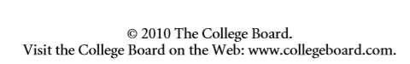

TAG | Background info for thesis | C and C | Conquer Answer
T: Letter to Thomas Jefferson  A(Speaker):  Benjamin Banneker  G: Letter (Epistle) | - Son of former slaves  - Rich industrial and academic background  - Writing to Jefferson in 1791  - Jefferson framed the Declaration of Independence | Command:  Analyze[s] how Banneker uses rhetorical strategies to argue against slavery.  Conquer:  What is his argument against slavery? | Slavery stands in direct contrast to the ideals that founded the U.S.
Without Considering Elements of Purpose in the Conquer Answer:

Considering Elements of Purpose in the Conquer Answer:
TAG | Background info for thesis | C and C | Conquer Answer
T: Letter to Thomas Jefferson  A(Speaker):  Benjamin Banneker  G: Letter (Epistle) | - Son of former slaves  - Rich industrial and academic background  - Writing to Jefferson in 1791  - Jefferson framed the Declaration of Independence | Command:  Analyze[s] how Banneker uses rhetorical strategies to argue against slavery.  Conquer:  What is his argument against slavery? | To Inform: Jefferson of the hypocrisy of slavery, especially in relation to founding American ideals  To Persuade: Jefferson to recognize his own hypocrisy and move to politically abolish it

A Garden of English Production: GardenofEnglish2019©

Prompt: Florence Kelley (1859-1932) was a United States social worker and reformer who fought successfully for child labor laws and improved conditions for working women. She delivered the following speech before the convention of the National American Woman Suffrage Association in Philadelphia on July 22, 1905. Read the speech carefully. Then write an essay in which you analyze the rhetorical strategies Kelley uses to convey her message about child labor to her audience. Support your analysis with specific references to the text.
Write out the Conquer Question:

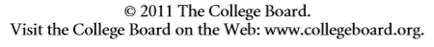

Without Considering Elements of Purpose in the Conquer Answer:
TAG | Background info for thesis | C and C | Conquer Answer
T: Speech at the NAWSA in Philadelphia  A(Speaker): Florence Kelley  G: Speech | - Social worker and reformer  - Successfully fought for child labor laws  - Speech happened in 1905 in Philadelphia | Command:  Analyze the rhetorical strategies Kelley uses to convey her message about child labor to her audience.  Conquer:  What is her message about child labor? | It is a torturous tragedy that can and should be stopped

Considering Elements of Purpose in the Conquer Answer:

TAG | Background info for thesis | C and C | Conquer Answer
T: Speech at the NAWSA in Philadelphia  A(Speaker): Florence Kelley  G: Speech | - Social worker and reformer  - Successfully fought for child labor laws  - Speech happened in 1905 in Philadelphia | Command:  Analyze the rhetorical strategies Kelley uses to convey her message about child labor to her audience.  Conquer:  What is her message about child labor? | To inform: Sympathetic men and women that it is a torturous tragedy that can and should be stopped  To Persuade: Sympathetic men and women to advocate for voting rights that will help enact more stringent laws for the sake of the children.

I’ll include a few more examples of finding the Command and Conquer in action as the document goes on, and later on in this document, I’ll actually include an annotated version of the Abigail Adam’s rhetorical analysis prompt from the 2015 exam as an example of how kids should mark all of this on their exams. Note, however, that for the first half of the year, I make students use the tables as seen throughout this piece. Once I know they know the process, I have them mark the prompt itself.

I hope that the above examples are clear, and should you go look at the past rhetorical analysis prompts, you will find that all—except one, which is the Alfred M. Green prompt—can be broken down in this way. Also, you will notice that whether you answer the Conquer Question by separating elements of purpose or not, the answers are similar; however, separating the answer out into the inform and persuade model provides students with a more specific and complex answer to the question, consequently requiring more complex analysis from them.
A Garden of English Production: GardenofEnglish2019©

Transitioning to Writing: Purposeful Essays

So, what is the point of me telling you all of this? Well, here it comes: when students have the Conquer Question, they now know what they need to comprehend once they are done reading the essay. If they can answer the question, they can write this paper, and they can do it well. Why can I say this? Because the next step for students is to go into the text and find 6 pieces of evidence that allowed each of THEM, to come to the answer to the question. (I make my students find two pieces from the beginning, two from the middle, and two from the end.) This then becomes their textual evidence for their essay, and it all relates to the abstraction—the answer to the Conquer Question—the prompt is asking them to analyze. Once students find their textual evidence, all students need to do is say what the author is DOING (ACTION VERBS—NEVER “USES”) in each piece of text, and the paper is practically written. Take a peek below to see view how the Conquer Question helps motivate analytical writing. You will find multiple examples: two are from Julius Caesar—which I will use to showcase how the Command/Conquer technique works when a student does and does not provide analysis focusing on the layers of purpose—and the third example will be based on the Abigail Adams letter to her son (from the 2014 exam)—which will showcase how the Command/Conquer technique works when a student does provide analysis focusing on the layers of purpose.
Portia rhetorical analysis prompt: In Act II, scene i of Julius Caesar, Shakespeare details a conversation—that happens on “the Ides of March”—between Brutus and his wife. Read the conversation carefully; then, analyze how Portia uses rhetorical strategies to evoke her intended emotions from her husband.

Without Blatantly Considering Elements of Purpose
TAG | Exigence to add to Thesis | C and C | Answer(s) to the Conquer
Title:  Julius Caesar  Author:  Shakespeare  Genre:  Play  Speaker:  Portia  Audience:  Brutus | - Brutus and Portia are married  - The conversation happened on the “Ides of March” | Command:  Analyze how Portia uses rhetorical strategies to evoke her intended emotional response from Brutus.  Conquer:  What emotions does Portia intend to evoke from her husband? | She intends on making Brutus feel pity and guilt
A Garden of English Production: GardenofEnglish2019©
Rhetorical Strategy  (What is the speaker doing?) | Textual Example (Evidence that shows ME  the answer to the Conquer Question) | Conquer Answer
Embraces a submissive posture  Challenges Brutus’s devotion  Demeans their relationship | “Upon my knees I charm you” (II.ii.279-280)  “Dwell I but in the suburbs/ Of your good pleasure?” (II.i.294-295)  “Portia is Brutus’ harlot, not his wife” (II.i.296) | She intends on making Brutus feel pity and guilt

In the prior example, I want to draw your attention to the rhetorical strategy column. This is where most students think they need to “bust out” all of their rhetorical and literary terms and whatnot, but what really needs to happen here is that kids need to clearly, and for some, simply, say what the speaker is doing. So, please note that there are many ways to say what Portia is doing for the second strategy that is labeled. Someone may say she, “Questions her husband’s love,” or someone else may say—for the third piece of evidence—something as simple as she “calls herself a prostitute.” The point is that strategies are action verbs, not nouns (which most rhetorical terms are). Because students are so used to finding the nouns—or just ethos, pathos, and logos (which aren’t even devices)—and linking them to the verb “uses,” no wonder they struggle with providing analysis. Think about it. If I were to ask someone, “How did you build that house?” and the response was, “Well, I used a hammer, wood, and nails.” I would never know HOW it was built. Using powerful verbs, and kissing the rhetorical jargon goodbye is a powerful way to empower students. Please don’t misunderstand me and think that I’m advocating that students not learn rhetorical devices; I’m not. In fact, if students can use specific rhetorical terms in conjunction with powerful verbs, they will be much more sophisticated in their analysis. Rather, though, I am suggesting that rhetorical jargon is not the be all and end all when analyzing rhetoric. In fact, I think it can often be quite limiting for many students. Anyway, using powerful verbs, and linking them to a strong thesis template—that includes the answer to the Conquer Question—is an even better way to empower students, because they are no longer writing about what they think their English teacher wants to hear, but rather what they know the author is doing for a specific purpose. If a student fills in the template with the correct information, s/he will also organize his/her whole essay, and the rest should be quite simple. Check out how this breakdown from the chart above works with my first template: THE THESIS.

THESIS TEMPLATE:

In the ______(Genre)____ ___(Title)___, (Contextual Information about Author and/or Text) (Author’s Name) (Rhetorical Choice 1), (Rhetorical Choice 2), (Rhetorical Choice 3) in order to ____(Answer to Conquer—Understand (Inform))____, ultimately moving (the audience) to ____(Answer to Conquer—Do (Persuade))____.

E.g.
In Act II.ii of Julius Caesar, by William Shakespeare, Portia—Brutus’s wife—embraces a submissive posture and demeans their relationship in order to get him to feel pity and guilt towards her, ultimately prompting him to reveal his troubles.
I think we can all agree that the example thesis reads much better than something along the lines of “Portia uses ethos, pathos, and logos in order to evoke emotions from her husband.” (That last line is similar to what I read so much of during the 2015 reading when I was scoring question 2 (The Chavez piece)).
I’ll give you some more examples of thesis statements in the templated format a little later, but I do want to move you toward my next template. Now, my next template is mechanical and repetitive, but it FORCES the students to provide analysis focused on the central purpose of a piece. I FORCE my students to use this template for the first half of the year, and then I show them how to provide variation. (This analytical template works for literature as well) Basically, I force the students to pull almost everything they write about in their body paragraphs word-for-word from their thesis. I call this next template my What/Why, Where, How? structure. I created it based on reading too many rhetorical analysis essays for AP Lang, and too many question 1 and 2 essays for AP Lit. (I teach both and those prompts on the Lit exam are constructed the same way as the rhetorical analysis.) I have come to notice that all of the best papers seem to have topic sentences that identify what an author is doing and why. They follow with the example in the text, and then they explain how the example relates to why the author is doing what s/he does in the piece. Most paragraphs then shift to addressing one more strategy in the same manner before moving onto the next paragraph where the structure resets. After I developed this format, I noticed the College Board published the following in 2013, and my structure was confirmed: Taken from Question 2 overview from 2013: “In short, rhetorical analysis means explaining not only what writers are saying but also why and how they are saying it.”
A Garden of English Production: GardenofEnglish2019©

BODY PARAGRAPH TEMPLATE:

Topic Sentence(What/Why): (Ordering Phrase—See Rhetorical Stems), (Author) (Rhetorical Choice from thesis) in order to (answer to the Conquer Question).
Textual Evidence (Where): Take, for example, how (insert context and textual evidence that shows the strategy referenced in the topic sentence in action) (citation).
Analysis (How): This (summary of text for analysis that is derived from quote) (strong analytical verb—often found in the topic sentence) (purpose (inform) found after “in order to” as seen in the topic sentence) because (explain how the textual evidence reveals the purpose/effect/answer to the understand element of the conquer question; this is usually done in at least two sentences. These explanations often focus on explaining general assumptions, stereotypes, and word connotations. Make sure to purposefully select your verbs to provide vibrant analysis).
Final Sentence(s): All of this would move (the audience) to (purpose (do/persuade) from thesis) because (explain how the information provided by the author would move the audience to act as identified.)
Note: Stronger paragraphs cover at least two strategies and/or examples at a time. So, feel free to enter another strategy after your analysis and start the process over. Usually the second strategy comes from the section of text you are exploring with your first strategy, so all you need to do is see if you can notice something else the author is DOING within the section. If you can’t find anything else, however, move on: it’s cool. When your paragraph explores two strategies, note that it will be beefy, but it will put you in position to score an upper-half essay if you do it right. Add another (maybe two) more doubled-up paragraphs—and make sure you have covered the whole text you are asked to analyze—and you will have one of the highest scores on this bad boy (not that it is actually gender specific).

In the following example, notice how I use the evidence from my chart—two pages ago—to give my thesis the substance it needs to direct my paper. Also notice the importance of the word “because” in conjunction with other powerful, connotative verbs. Having the kids use the word “because” and focus on verb use forces them to attempt to provide analysis. I make my students highlight these words in their papers all the time! Lastly, notice that my analysis often focuses on explaining word connotations and stereotypical interpretations and assumptions. (Remember, the example below would be considered adequate, the one that could be considered effective comes after.)
Body Paragraphs (Without Considering Layers of Purpose)

First, Portia submissively postures herself in order to get Brutus to feel guilty for not telling her what is bothering him. Take, for example, how Portia, after asking Brutus what is wrong with him and receiving a dishonest response, approaches her husband “upon [her] knees” (II. ii. 270). This would cause Brutus to feel guilty because his wife is embracing a posture of someone who is begging. By putting herself in such a lowly state, she is expressing how Brutus is being so cold that she has no other choice but to vulnerably position herself as a slave and/or commoner, not his wife. When Brutus doesn’t reveal the information she desires, Portia challenges Brutus’s devotion to their marriage by questioning if she, “Dwell[s]…but in the suburbs of [his] good pleasure?” (II.i.294-295). Doing such would potentially lead Brutus to feel guilty because it exposes how poorly Portia feels like she is being treated. Portia, in this instance, makes it seem as though the only way he can prove his love to her is by revealing why he is so troubled, and if he doesn’t, it must mean he loves her not. Knowing that he does love her, Brutus should feel guilty for even leading her to consider that she is unloved.
Portia also blatantly demeans her romantic relationship with her husband in order to get Brutus to feel guilty for not telling her what is bothering him. Take, for example, how after her initial tactics fail, she asserts that if he cannot tell her his concerns then “Portia is Brutus’ harlot, not his wife” (II.i.296). This would evoke guilt from Brutus because, by keeping secrets from his wife, he is causing her to devalue herself; she suggests he is using her like a worthless sex slave, a mere pleasure puppet. Seeing as though he views Portia as a “true […] honorable […and…] noble wife” (II.i.297), it’s implied that he would never want his wife to feel this way…
A Garden of English Production: GardenofEnglish2019©

Now, if you read the prior example, particularly the first paragraph, you will notice that a second strategy (indicated by the underlined italics) is introduced in the middle of the paragraph. You may also notice that this second strategy is NOT in the thesis. I tell students that the strategies that are listed in their thesis should be the ones that will be included in their topic sentences. This then guides their paragraphs; however, each paragraph should have a subsequent strategy—often derived from another chronological movement—that analyzes some text that comes in between the text of the strategies listed in the thesis. You will also notice the bold verbs that show up in the analysis in each paragraph. Not only does the word “because” or any of its variants (e.g., due to, since, on the account of, etc.) prompt and demonstrate analysis, but so too is the case with strong, connotative verbs. Such verbs showcase inferential judgments and should be highly valued.

Although this essay is mechanical—and not finished, as it is an example—it is clearly driven by the thesis, it is centered around the emotions Brutus is supposed to feel as directed from the prompt, and it allows students to explain what they know based on the evidence they’ve found. Furthermore, and I can say this with surety as I was scoring RA papers in 2015, this paper would score at least a 4/6—if it were finished in like manner—as it is clearly adequate; it’s not amazing, but it shows that the student can analyze rhetoric. Now, if the paper did continue to cover the whole text in like manner, the fact that it would explore the piece so conclusively could actually net it a 5 under the scoring guide requirement that the essay include a sophisticated understanding of the rhetorical situation.

The next rendition of these paragraphs will look at the same text and utilize the same language, yet you’ll notice that these paragraphs are a bit longer. This is because these paragraphs have moved past just analyzing how Portia evokes Brutus’s emotions; in these paragraphs, you’ll notice the added language—highlighted in yellow—ties together Portia’s argument—that she feels violated—with not only the emotions she’s trying to evoke from her husband, but also her true intent: getting Brutus to reveal his secrets. Her argument is what she wants him to understand (to inform), responding emotionally and telling her his secrets is what she wants him to do (to persuade). This means that these paragraphs will shift through three layers, sometimes simultaneously, but in doing so, the paper will at least score a 5/6, and probably an 6/6, because the analysis is effective and therefore sophisticated.

Considering Elements of Purpose in the Conquer Answer
TAG | Exigence to add to Thesis | C and C | Answer(s) to the Conquer
Title:  Julius Caesar  Author:  Shakespeare  Genre:  Play  Speaker:  Portia  Audience:  Brutus | - Brutus and Portia are married  - The conversation happened on the “Ides of March” | Command:  Analyze how Portia uses rhetorical strategies to evoke her intended emotional response from Brutus.  Conquer:  What is Portia’s purpose? | To Inform:  Brutus that she feels as though he is violating their marriage vows  To Persuade:  Brutus to feel pity and guilt, ultimately causing him to reveal why he’s so troubled.

Body Paragraphs (Considering Layers of Purpose)

First, Portia submissively postures herself in order to get Brutus to feel guilty for not telling her what is bothering him. Take, for example, how Portia, after asking Brutus what is wrong with him and receiving a dishonest response, approaches her husband “upon [her] knees” (II. ii. 270). This would cause Brutus to feel guilty because his wife is embracing a posture of someone who is begging. By putting herself in such a lowly state, she is expressing how Brutus is being so cold that she has no other choice but to vulnerably position herself as a slave and/or commoner, not his wife. She strips herself of her status, and in doing so, hopes to evoke pity from Brutus because if he pities her, he may tell her the cause of his emotional turmoil. When Brutus doesn’t reveal the information
A Garden of English Production: GardenofEnglish2019©

she desires, Portia challenges Brutus’s devotion to their marriage by questioning if she, “Dwell[s]…but in the suburbs of [his] good pleasure?” (II.i.294-295). Doing such would potentially lead Brutus to feel guilty because it exposes how poorly Portia feels like she is being treated. Brutus wouldn’t want his wife to believe that she isn’t “in [his] good pleasure,” so he should be moved to prove this by telling her his secrets. Portia, in this instance, makes it seem as though the only way he can prove his love to her is by revealing why he is so troubled, and if he doesn’t, it must mean he loves her not. Knowing that he does love her, Brutus should feel guilty for even leading her to consider that she is unloved, which continues to promote the potential revelation of his inner turmoil.
Portia also blatantly demeans her romantic relationship with her husband in order to get Brutus to feel guilty for not telling her what is bothering him. Take, for example, how after her initial tactics fail, she asserts that if he cannot tell her his concerns then “Portia is Brutus’ harlot, not his wife” (II.i.296). This would evoke guilt from Brutus because, by keeping secrets from his wife, he is causing her to devalue herself; she suggests he is using her like a worthless sex slave, a mere pleasure puppet. Seeing as though he views Portia as a “true […] honorable […and…] noble wife” (II.i.297), it’s implied that he would never want his wife to feel this way. Knowing that her husband does lover her, Portia makes it seem that if Brutus tells her his secret, she will no longer feel so violated, ultimately—in her mind—leaving Brutus with no other option but to reaffirm his deepest affections for his wife.

Below is another example of the Command/Conquer method in action; but remember, this example will only be looking at providing analysis when applying the layers of purpose. I will not provide an example of what this looks like when I don’t. I’m going to produce a thesis and one body paragraph; however, this time I’m going to do a few new things: 1) I’m going to provide two thesis statements. The first is going to be the generic thesis that just contains the answer to the Conquer Question with integrated elements of purpose. The second thesis is going to exemplify what it means when the thesis template mentions “Better with Quote.” That is, I’m going to find a piece of textual evidence to add to the thesis that will help satisfy complexly identifying the Conquer answer. 2) I’m going to provide two versions of the same body paragraph; however, the second body paragraph will illustrate how students can integrate textual evidence into their analysis as well. This will be marked by a bulleted underline. 3) I’m going to provide some instructions and steps that students can take in order to create meaningful conclusions for rhetorical analysis essays.

So, let’s start with the prompt breakdown and work from there.
2014: In the following letter, Abigail Adams (1744–1818) writes to her son John Quincy Adams, who is traveling abroad with his father, John Adams, a United States diplomat and later the country’s second president. Read the letter carefully. Then, in a well-developed essay, analyze the rhetorical strategies Adams uses to advise her son. Support your analysis with specific references to the text.

Considering Elements of Purpose in the Conquer Answer
A Garden of English Production: GardenofEnglish2019©
TAG | Exigence to add to Thesis | C and C | Answer(s) to the Conquer
Title:  Letter to her son, John Q. Adams  Author:  Abigail Adams  Genre:  Letter (Epistle) | - Written to her son while he is traveling abroad  - Son is traveling with diplomat father  - (Not found in prompt but at the beginning of letter) Letter was written in 1780 | Command:  Analyze the rhetorical strategies Adams uses to advise her son.  Conquer:  What does Abigail Adams advise her son? | To Inform:  Her son that he has been blessed with immense privilege and potential yet is lacking in maturity  To Persuade:  Her son to allow this trip to build his character

Thesis 1:

Throughout her epistle to her traveling son, John Quincy Adams (JQA), Abigail Adams—a future first lady and historical icon—exposes his naiveté, references enriching metaphors, and provides examples of honorable role models in order to remind him of his privileged position in life and subsequently prompt him to seek the personal value of his advantageous trip.
Body Paragraph 1: (Without Text in Analysis)

Abigail Adams exposes her son’s naiveté in order to highlight his need to find value in both his current voyage and his privileged upbringing. Take, for example, how after kindly beginning her letter, Adams reminds her son of the “reluctance” he had toward going on the trip which didn’t—in her mind—“ar[i]se from proper deliberation,” as he was seemingly not “capable of judging what was most for [his] own benefit” (4-5) at the time. This highlights her son’s need to improve his character because she focuses on her son’s lack of meaningful foresight. In reminding him of his desire not to travel, she clarifies that he was in the wrong, exposing him to his character flaws; however, she doesn’t blame him. Instead, she caringly links his being “[in]capable of judging” things for himself to a lack of maturity, not overtly capricious thought patterns. This is important because, although she does reference his potential insubordination prior to the trip, she refuses to discourage his spirit by focusing on it. This shifting of the blame eases the severity of her reminder, and doing this allows Adams to present herself as a loving mother who knows how to identify the exact needs of her children. As her son reflects on both his initial “avers[ion]” and his mother’s care, he’s forced to consider the privilege it is to have a mother who is willing to do what it take for her son’s “own benefit” (5): in this case, forcing him to go on a trip to gain the life experiences he needs to mature into the man she know he can be. Although she softens the blow in criticizing her son’s initial actions, knowing that demoralizing her son would not cause him to value the trip, Adams follows the above reminder with praise for his maturing potential. She goes on to remind JQA that he “readily submitted to [her] advice” (9) and now has “knowledge of the language”(10) that can offer him “greater advantages” (11) on his journey. Recalling her son’s eventual response to her urging provides him with a sense of hope because it showcases that his mother views his final judgment prior to the trip in a positive light. Although he will know that she has not forgotten that he appeared “so averse” (7), he should also realize that she values his obedience all the more, as it reveals his ability to make good judgements, an ability he apparently lacked at the beginning of her first paragraph. Furthermore, being reminded that he knows the language and will now be more prepared for what’s in store will also assist him in finding value in his current trip because he’s forced to recognize the benefits of his newfound skill. By pairing the skill of learning the language with his positive judgement, Adams successfully illustrates for her son that experiences provide advantages. In a similar manner to having practiced and learned a language, her son is being forced to recognize that experiencing life leads to similar outcomes, especially if positive judgments dictate his actions. Because he knows that his mother cares for him, and that his positive judgments have—in her mind—put him in a better place, once this is proven to him, he should be more apt to value the trip because doing so would not only make his mother proud, but also allow him to continue maturing….(I would then move to paragraph 2 which would begin with the second strategy listed in the thesis.)

I know that my templates are mechanical, but every year my students outperform the global average on their rhetorical analysis essays. I also use my templates to then springboard into variation and ultimately—if we have time—voice development. The following is an example of how I teach students to do more with the text than just use it as evidence. This paragraph not only has textual evidence, but simply exchanges some ideas in my original analysis with words from the text (indicated by the bulleted underline). Although this seems like a simple move, it demonstrates a control over the text, and as I say to my students, “Let your readers know that you have married the text and that you have a pathetic relationship: you even finish each other’s sentences.”
Check it out:
A Garden of English Production: GardenofEnglish2019©
Body Paragraph 1: (With Text in Analysis)

Abigail Adams exposes her son’s naiveté in order to highlight his need to find value in both his current voyage and his privileged upbringing. Take, for example, how after kindly beginning her letter, Adams reminds her son of the “reluctance” he had toward going on the trip which didn’t—in her mind—“ar[i]se from proper deliberation,” as he was seemingly not “capable of judging what was most for [his] own benefit” (4-5) at the time. This highlights her son’s need to improve his character because she focuses on her son’s lack of meaningful foresight. In reminding him of his desire not to travel, she clarifies that he was in the wrong, exposing him to his character flaws; however, she doesn’t blame him. Instead, she caringly links his being “[in]capable of judging” things for himself to a lack of maturity, not overtly capricious thought patterns. This is important because, although she does reference his potential insubordination prior to the trip, she refuses to discourage his spirit by focusing on it; this shifting of the blame eases the severity of her reminder; he only acted the way he did “whilst ignorant” (13). Doing this allows Adams to present herself as a loving mother who knows how to identify the exact needs of her children. As her son reflects on both his initial “avers[ion]” and his mother’s care, he’s forced to consider the privilege it is to have an “affectionate mother”(63) who is willing to do what it take for her son’s “own benefit” (5): in this case, “urg[ing] [him] to accompany [his] father and brother” (6-7) to gain the life experiences he needs to mature into the “good citizen” (60-61) she knows he can be. Although she softens the blow in criticizing her son’s initial actions, knowing that demoralizing her son would not cause him to value the trip, Adams follows the above reminder by praising his maturing potential. She also reminds JQA that he “readily submitted to [her] advice” (9) and now has “knowledge of the language”(10) that can offer him “greater advantages” (11) on his journey. Recalling her son’s eventual response to her urging provides him with a sense of hope because it showcases that his mother views his final judgment prior to the trip in a positive light. Although he knows that she remembers he appeared “so averse” (7), he should also realize that she values his obedience all the more, as it showcases his ability to make good judgements, an ability he apparently lacked at the beginning of her first paragraph. Furthermore, being reminded that he knows the language and will now be more prepared for what’s in store will assist him in finding value in his current trip because he’s forced to recognize the benefits of his newfound skill. By pairing the skill of learning the language with his positive judgement, Adams successfully illustrates for her son that experiences provide advantages. In a similar manner to having practiced and learned a language, her son is forced to recognize that experiencing life will lead to his “understanding opening and daily improving” (14-15), especially if positive judgments dictate his actions. Because he knows that his mother cares for him, and that his positive judgments have—in her mind—put him in a better place, once this is proven to him, he should be potentially more willing to become “a judicious traveler” (17) because it would not only make his mother “supremely happy” (62), but also allow him to continue maturing….(I would then move to paragraph 2 which would begin with the second strategy listed in the thesis.)

Conclusions: Channeling One’s Inner Cinderella
Constructing Conclusion Paragraphs for Rhetorical Analysis Essays:
When constructing conclusions, kids need to channel their inner Cinderella--yes, even your toughest football player has an inner Disney Princess--and leave a glass slipper. If a student's conclusion doesn't leave the reader (his/her Prince Charming) desiring to search the country for him/her, then the conclusion is NO GOOD! When writing conclusions for Rhetorical Analysis essays, students, rather than summarizing their essays and strategies/devices, should highlight the ideas the RA Essay Speaker showcases and apply them universally. I have included examples—the first taken from an essay responding to a home-made prompt about Fast Food Nation, the other created in response to the Abigail Adams piece (2014)—in the steps below:
A Garden of English Production: GardenofEnglish2019©
      - Students must identify 2-3 key ideas—singular abstract words—to which the analyzed
piece relates.
E.g.
Chapter 9 of Fast Food Nation: Corporate Greed, Apathy, Empathy

Abigail Adams’ letter: Struggle, Maturity, Anxiety, Compassion, Love, Encouragement, Inspiration

      - With those ideas, students must write a sentence that ties one or all of them to the purpose
of the speaker; do not list out any rhetorical strategies; conclusions are about ideas. (To do
this with style, students should try turning the first sentence of their conclusions into a
metaphor.)

E.g. The meatpacking industry has, for far too long, been given free reign over their companies; in chapter nine Schlosser delves into the disgust and betrayal of the industry, promoting the imperative need for stricter regulations.

(Style) Throughout chapter 9, Eric Schlosser forces the American public to wade through the cesspool that is the American meat packing industry.

E.g. Abigail Adams inspires her son amidst perhaps the most tumultuous time of his life (literally and figuratively): his teenage years.

(Style) Throughout the piece, Abigail Adams strives to help her son navigate the tumultuous seas of adolescence.

      - Students must highlight the ideas that the paper explores by putting them into a universally
applicable model and/or make the audience respond to said ideas, but never by asking a
question. (Channel your inner Cinderella and leave your glass slipper!)

E.g. After experiencing these horrifying truths, hopefully, in the future, the American people will teach their young to covet their peers more than profits. Then, no longer will corporations be willing to throw away the lives of their consumers—which are more valuable than any price tag—because their directors will understand that a single human being should be cherished by all.

E.g. By embracing her matriarchal role, she serves as a model to all who seek to correct those with less experience: she exemplifies that one must never shy away from exposing acts of naiveté; however, such criticism must be simultaneously paired with encouraging words and, most important of all, love.

Below is how each conclusion would look based on the completion of the steps detailed on the prior page.
Fast Food Nation Response—General:
The meatpacking industry has, for far too long, been given free reign over their companies; in chapter nine Schlosser delves into the disgust and betrayal of the industry, promoting the imperative need for stricter regulations. After experiencing these horrifying truths, hopefully, in the future, the American people will teach their young to covet their peers more than profits. Then, no longer will corporations be willing to throw away the lives of their consumers—which are more valuable than any price tag—because their directors will understand that a single human being should be cherished by all.
A Garden of English Production: GardenofEnglish2019©

Fast Food Nation Response—Style:
Throughout chapter 9, Eric Schlosser forces the American public to wade through the cesspool that is the American meat packing industry. After experiencing his recorded horrifying truths, hopefully, in the future, the American people will teach their young to covet their peers more than profits. Then, no longer will corporations be willing to throw away the lives of their consumers—which are more valuable than any price tag—because their directors will understand that a single human being should be cherished by all.
Abigail Adams Response—General:
Abigail Adams inspires her son amidst perhaps the most tumultuous time of his life (literally and figuratively): his teenage years. By embracing her matriarchal role, she serves as a model to all who seek to correct those with less experience: she exemplifies that one must never shy away from exposing acts of naiveté; however, such criticism must be simultaneously paired with encouraging words and, most important of all, love.
Abigail Adams Response—Style:
Throughout the piece, Abigail Adams strives to help her son navigate the tumultuous seas of adolescence. By embracing her matriarchal role, she serves as a model to all who seek to correct those with less experience: she exemplifies that one must never shy away from exposing acts of naiveté; however, such criticism must be simultaneously paired with encouraging words and, most important of all, love.

I am convinced that any teacher or reader would prefer the above to: (I know the following may be hyperbolically oversimplified; sorry.)
In this piece, Schlosser effectively uses pathos and describes disgusting practices to evoke emotions. He also uses logos when he talks about the scientific language
Or
In this piece Adams relies heavily on pathos in order to advise her son. She also alludes to past historical figures, and the Revolutionary War. (Or something that just repeats strategies or devices.)

A Garden of English Production: GardenofEnglish2019©

Template Quick Guide
Thesis Template:
In the ______(Genre)____ ___(Title)___, (Contextual Information about Author and/or Text) (Author’s Name) (Rhetorical Choice 1), (Rhetorical Choice 2), (Rhetorical Choice 3) in order to (Answer to Conquer—Understand (Inform)), ultimately moving (the audience) to (Answer to Conquer—Do (Persuade)).

BODY PARAGRAPH TEMPLATE:

Topic Sentence(What/Why): (Ordering Phrase—See Rhetorical Stems), (Author) (Rhetorical Choice from thesis) in order to (answer to the Conquer Question).
Textual Evidence (Where): Take, for example, how (insert context and textual evidence that shows the strategy referenced in the topic sentence in action) (citation).
Analysis (How): This (summary of text for analysis that is derived from quote) (strong analytical verb—often found in the topic sentence) (purpose (inform) found after “in order to” as seen in the topic sentence) because (explain how the textual evidence reveals the purpose/effect/answer to the understand element of the conquer question; this is usually done in at least two sentences. These explanations often focus on explaining general assumptions, stereotypes, and word connotations. Make sure to purposefully select your verbs to provide vibrant analysis).
Final Sentence(s): All of this would move (the audience) to (purpose (persuade) from thesis) because (explain how the information provided by the author would move the audience to act as identified.)
Note: Stronger paragraphs cover at least two strategies and/or examples at a time. So, feel free to enter another strategy after your analysis and start the process over. Usually the second strategy comes from the section of text you are exploring with your first strategy, so all you need to do is see if you can notice something else the author is DOING within the section. If you can’t find anything else, however, move on: it’s cool. When your paragraph explores two strategies, note that it will be beefy, but it will put you in position to score an upper-half essay (4,5,6) if you do it right. Add another (maybe two) more doubled-up paragraphs—and make sure you have covered the whole text you are asked to analyze—and you will have one of the highest scores on this bad boy (not that it is actually gender specific).

Analytical Template for Struggling Students:
This last template is for students who really struggle with analysis. It lets them know that they need to bring what they “know” to the table. I use this ONLY as a springboard and mandate that students then remove all first person references when they actually put it in their paragraphs. You will notice, however—should you try this with a struggling student—that when they remove the first-person element, there will be clear attempts at analysis. Check out my template and examples. Also note that there is an activity following this page that is intended to simplify the analytical task for students who struggle with understanding what they actually need to do when providing analysis.
Simplified Analysis: If I were (insert audience from prompt), (insert rhetorical strategy) would make me (answer to the Conquer Question) because (explain how it would move you toward the answer to the Conquer Question). To add this to your paragraph, GET RID OF THE FIRST PERSON NONSENSE!!!!!
If I were Brutus, Portia calling herself a prostitute would make me feel guilty because I am supposed to love her, and she doesn’t feel loved by me. Actually, she feels like I’m just using her for pleasure, but I have a deeper bond than that, so I must really be doing something to hurt her, and I don’t want that. But, I could potentially repair these damaged feelings if I told her my secret.
Transposed, removing the first-person: Portia calling herself a prostitute would make Brutus feel guilty because he is supposed to love her, but she doesn’t feel loved by him. Actually, she feels like she is being used for pleasure, but marriage is supposed to be about more than that. It’s about support. Brutus is led to consider that he must be the cause of her pain, and he shouldn’t want that for his wife. Because of this, he could be potentially moved to repair the damage by telling her his secrets.
A Garden of English Production: GardenofEnglish2019©

Simplifying Analysis Activity
- Open this:
- Find the following:
- Answer this: What Did I Do Over Vacation?

- How do you know?

When producing analysis, you are required to unpack the suitcase of language. You must explain how the words, phrases, and clauses (sentences) you identify reveal the overarching purpose of the piece.

(In the case—pun intended—above, this is explaining how each item answers the question found in step 3. In relation to your rhetorical analysis prompts, this is explaining how the language you are highlighting answers the conquer question.)
A Garden of English Production: GardenofEnglish2019©
The following interaction from II.i of Julius Caesar takes place after the conspirators held a secret mid-night meeting with Brutus. In this scene, Portia expresses her concern for her husband.
[Exeunt all but BRUTUS]
Boy! Lucius! Fast asleep? It is no matter;
Enjoy the honey-heavy dew of slumber:
Thou hast no figures nor no fantasies,
Which busy care draws in the brains of men;
Therefore thou sleep'st so sound.
Enter PORTIA
Portia. Brutus, my lord!
Brutus. Portia, what mean you? wherefore rise you now?
It is not for your health thus to commit
Your weak condition to the raw cold morning.
Portia. Nor for yours neither. You've ungently, Brutus,
Stole from my bed: and yesternight, at supper,
You suddenly arose, and walk'd about,
Musing and sighing, with your arms across,
And when I ask'd you what the matter was,
You stared upon me with ungentle looks;
I urged you further; then you scratch'd your head,
And too impatiently stamp'd with your foot;
Yet I insisted, yet you answer'd not,
But, with an angry wafture of your hand,
Gave sign for me to leave you: so I did;
Fearing to strengthen that impatience
Which seem'd too much enkindled, and withal
Hoping it was but an effect of humour,
Which sometime hath his hour with every man.
It will not let you eat, nor talk, nor sleep,
And could it work so much upon your shape
As it hath much prevail'd on your condition,
I should not know you, Brutus. Dear my lord,
Make me acquainted with your cause of grief.
Brutus. I am not well in health, and that is all.
Portia. Brutus is wise, and, were he not in health, 885
He would embrace the means to come by it.
Brutus. Why, so I do. Good Portia, go to bed.
Portia. Is Brutus sick? and is it physical
To walk unbraced and suck up the humours
Of the dank morning? What, is Brutus sick,
And will he steal out of his wholesome bed,
To dare the vile contagion of the night
And tempt the rheumy and unpurged air
To add unto his sickness? No, my Brutus;
You have some sick offence within your mind,
Which, by the right and virtue of my place,
I ought to know of: and, upon my knees,
I charm you, by my once-commended beauty,
By all your vows of love and that great vow
Which did incorporate and make us one,
That you unfold to me, yourself, your half,
Why you are heavy, and what men to-night
Have had to resort to you: for here have been
Some six or seven, who did hide their faces
Even from darkness.
Brutus. Kneel not, gentle Portia.
Portia. I should not need, if you were gentle Brutus.
Within the bond of marriage, tell me, Brutus,
Is it excepted I should know no secrets
That appertain to you? Am I yourself
But, as it were, in sort or limitation,
To keep with you at meals, comfort your bed,
And talk to you sometimes? Dwell I but in the suburbs
Of your good pleasure? If it be no more,
Portia is Brutus' harlot, not his wife. 915
Brutus. You are my true and honourable wife,
As dear to me as are the ruddy drops
That visit my sad heart
Portia. If this were true, then should I know this secret.
I grant I am a woman; but withal 920
A woman that Lord Brutus took to wife:
I grant I am a woman; but withal
A woman well-reputed, Cato's daughter.
Think you I am no stronger than my sex,
Being so father'd and so husbanded? 925
Tell me your counsels, I will not disclose 'em:
I have made strong proof of my constancy,
Giving myself a voluntary wound
Here, in the thigh: can I bear that with patience.
And not my husband's secrets? 930
Brutus. O ye gods,
Render me worthy of this noble wife!
[Knocking within]
Hark, hark! one knocks: Portia, go in awhile;
And by and by thy bosom shall partake 935
The secrets of my heart.
All my engagements I will construe to thee,
All the charactery of my sad brows:
Leave me with haste.
[Exit PORTIA]

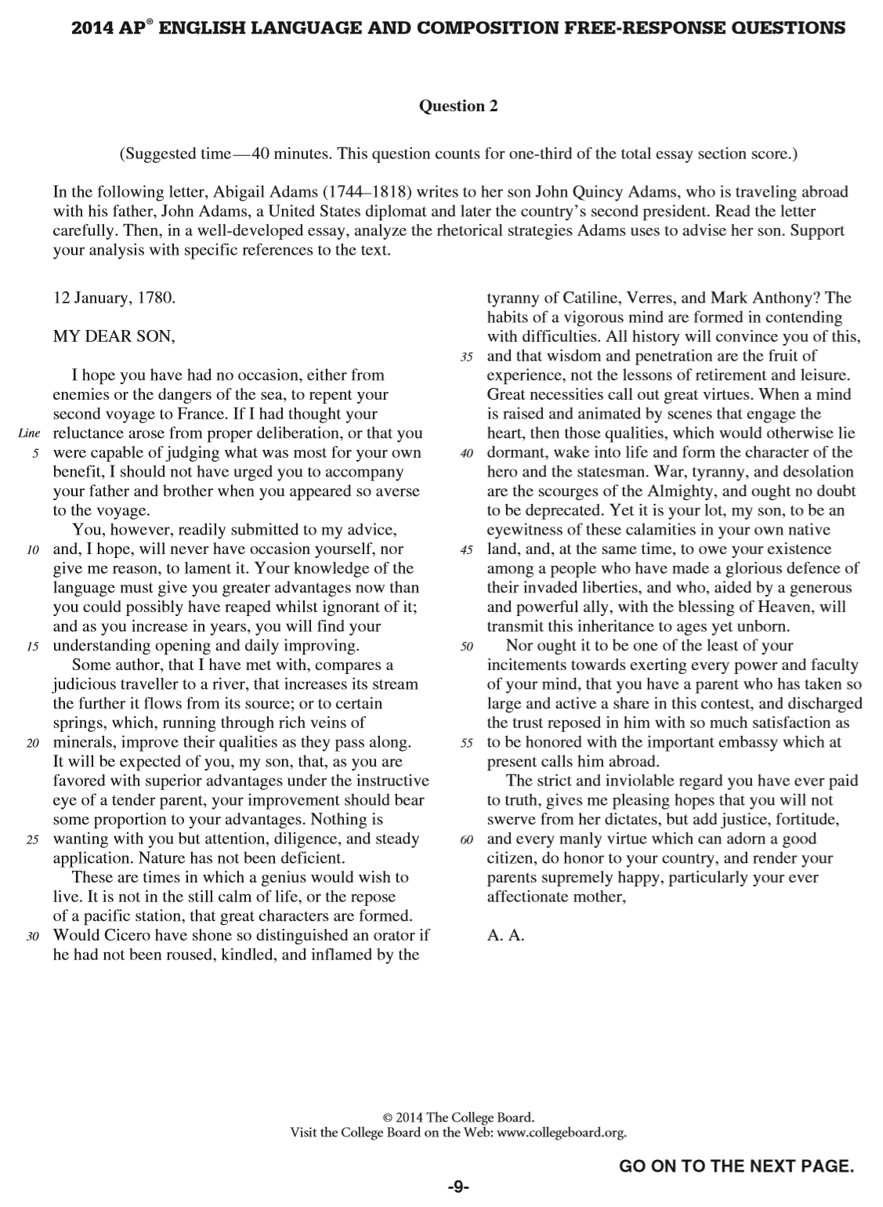

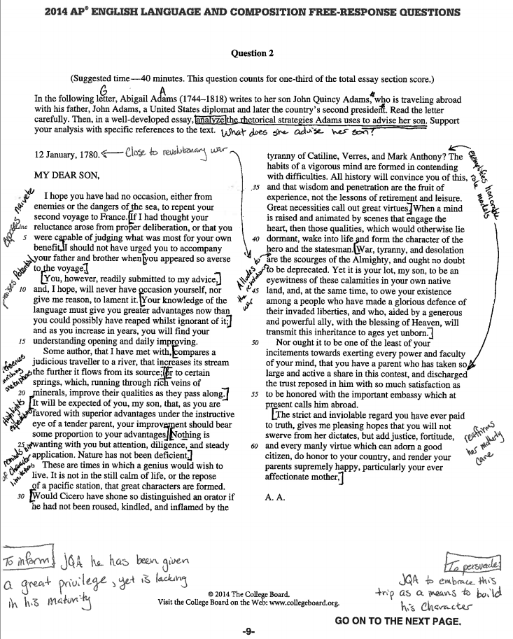

Authorial Statement and Organizational Stems:
A Garden of English Production: GardenofEnglish2019©

Beginning of Text:

(Speaker/Author) begins by/with…

Body of Text:

(Speaker/Author) follows this by/with…
Following this, (Speaker/Author) (action verb)…
Moving on, (Speaker/Author) (action verb)

(Speaker/Author) transitions to…
In order to transition, (Speaker/Author) (action verb)…
(Speaker/Author) then shifts to…

(Speaker/Author) moves to compare…
(Speaker/Author) then contrasts…
(Speaker/Author) exemplifies…

Conclusion of text:

(Speaker/Author) concludes by/with…
Finally, (Speaker/Author) reminds…

Analytical Addition (at the end of every authorial move):

…in order to…

A Garden of English Production: GardenofEnglish2019©
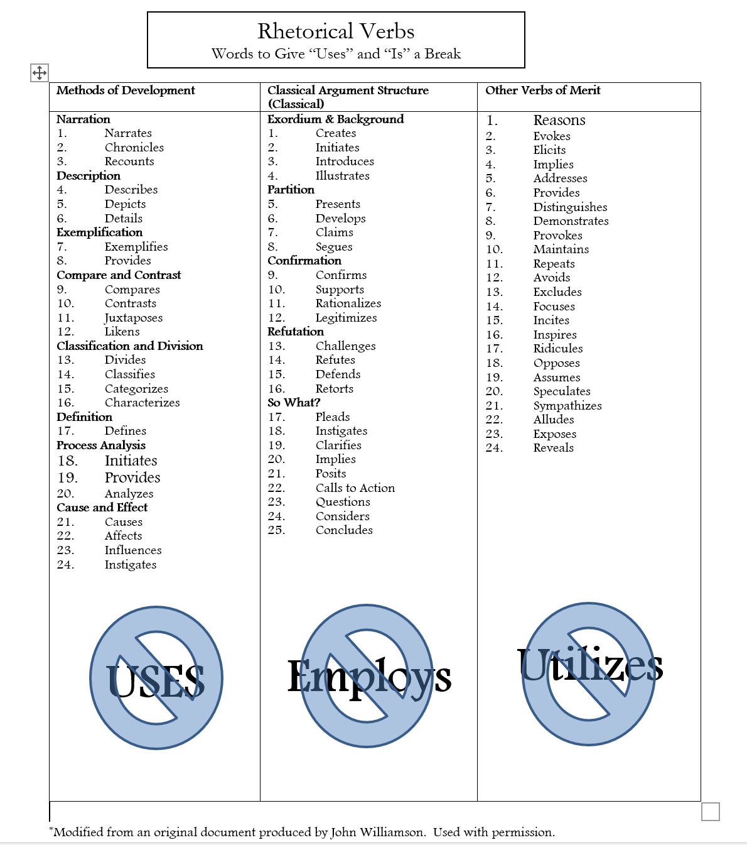
A Garden of English Production: GardenofEnglish2019©

This definition is important because it is accessible to students, and it shows students that rhetoric is a mixture of concrete (language) and abstract (meaning) layers
Students often write about rhetorical devices, not strategies. Also, when they write about devices, they limit what they speak about to the terms their English teacher has taught them. This often leads to essays that are less-than-optimally effective. Last, yet most important, devices are always nouns or pronouns.
Rhetorical Strategies will always be powerfully connotative verbs. You can find a list of excellent rhetorical verbs to use at the end of this document.
This information is used to create an appositive or non-essential in the thesis. This is important as integrating appositives and non-essentials are considered advanced writing techniques. Furthermore, elements of exigence may give hints toward the answer(s) to the Conquer Question.
I also make sure to define analyze for my students. I point out that analysis has three (3) parts: Identify, Break down, Explain (how). What is also important to note here is that once students understand these parts, it will help them structure their body paragraphs—covered later with templates—they must identify what the speaker is doing and why, they must break down and present the evidence seen in the text, and they must explain how the evidence informs the audience of what the author wants them to understand and subsequently moves the audience to do something in response to that information.
The basic characteristics of this breakdown model have been taken from a document originally created by Beth Priem. The ideas presented here have been modified with her permission.
A list of rhetorically-charged verbs can be found at the end of this document.
Modified with permission from a conclusion originally produced by Erik Martus (Blackstone Valley Tech. Class of 2017)
Modified with permission from a conclusion originally produced by Samantha Beauchamp (Blackstone Valley Tech. Class of 2017)
Modified with permission from a conclusion originally produced by Erik Martus (Blackstone Valley Tech. Class of 2017)

